Gavin McGill 59048032

The scene in the project shown is from the TV show spongebob in spongebob squarepants’s neighbourhood. The buildings displayed left to right are Patrick’s house made from a sphere, squidwards house which is made from multiple gl/glut objects the steps and door are made from planes that display textures. Finally spongebob’s house is made of a surface revolution with a basic texture mapped on top. In front of the buildings is a road with a car moving down it the car has working headlights if you press F1 you can control the car using W,A,S,D (you can press F2 to exit the car). Other features shown are spongebob running around a house, a treasure chest that opens and closes and Garry the snail that wanders around with no specific path.

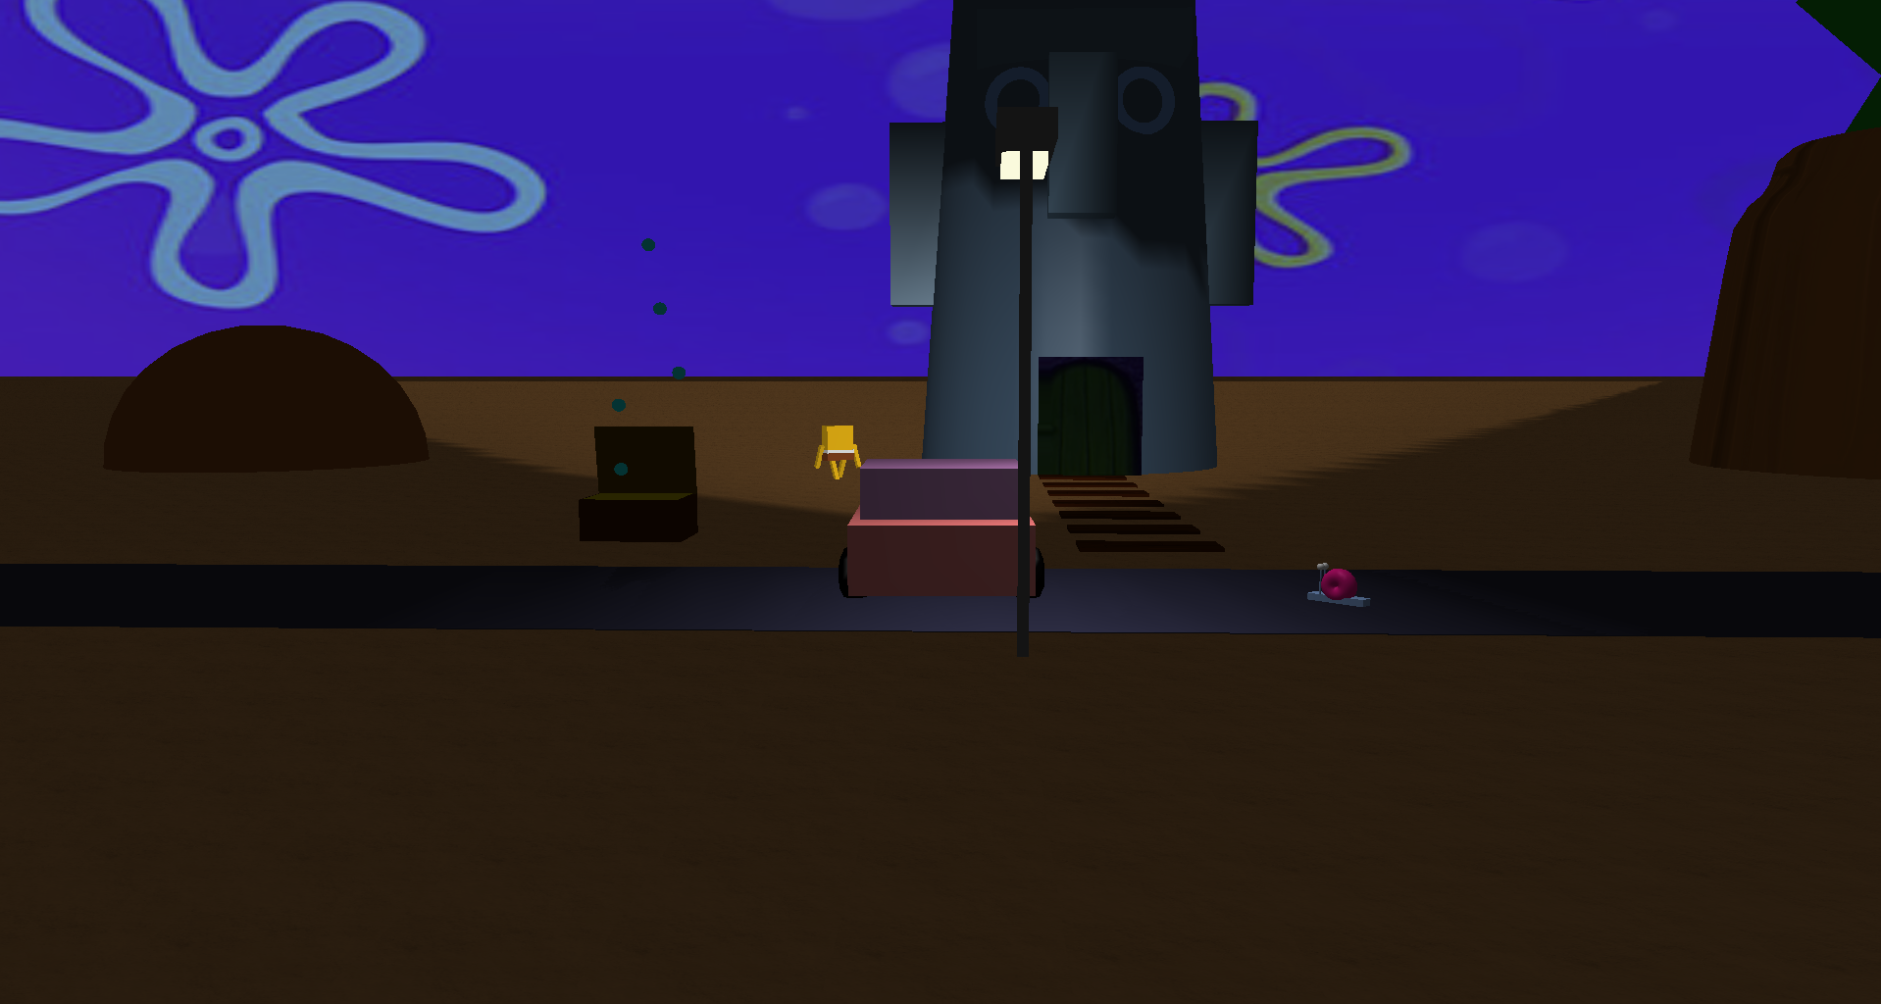

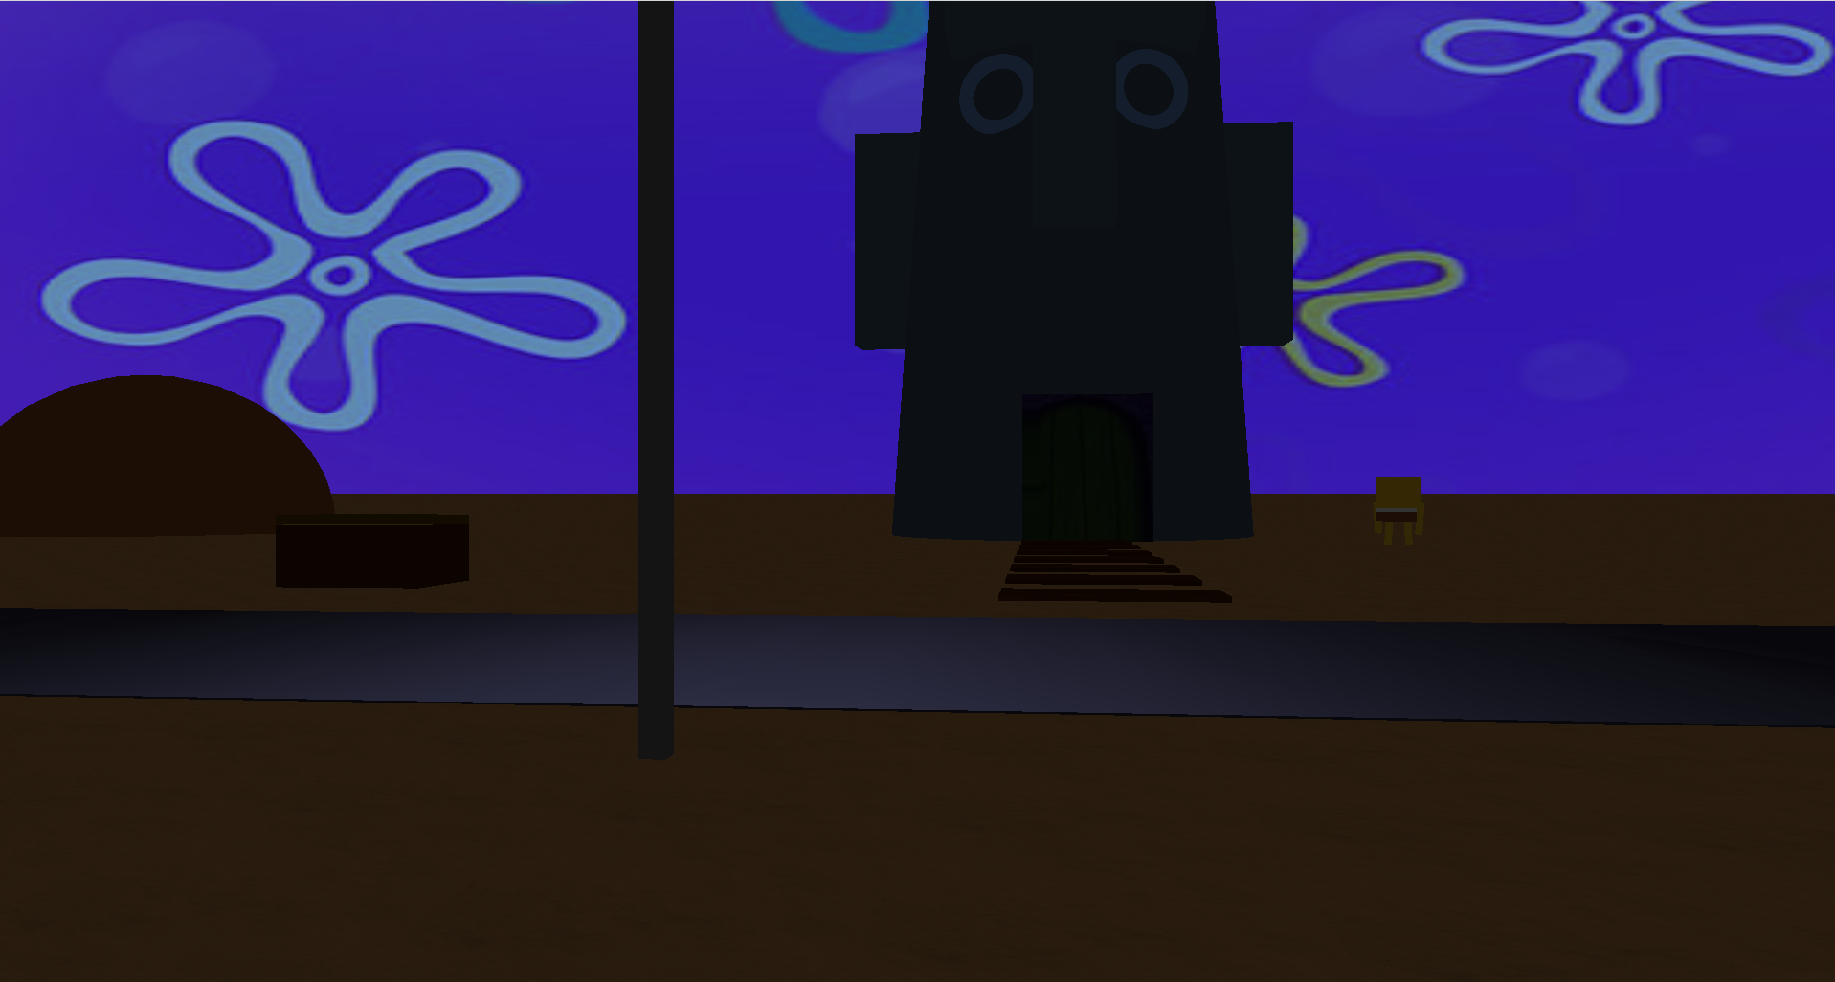

*Fig 1*. view while driving the car showing specular reflections of the top if the car and of squidwards house.

Fig 2. View while standing outside squidwards house showing the scene lit with little light.

For extra marks the following was implemented:

1. basic particle effects (bubbles coming out of the chest)

2. car physics

the car uses the following equation to map its position

carposx -= carspeed * cos(car_rotation);

carposz -= carspeed * sin(car_rotation);

The car also has friction physics when driving so it slows down when not accelerating.

3. The camera modes are changeable by pressing the F1 and F2 keys.

4. There is a spotlight on the car that acts as headlights.

Controls:

F1: Enter car

F2: Exit car

Walking:

W : Forward , S : Back, A : Turn Left, D Turn Right

Driving:

W : Accelerate , S : Break, A : Turn Left, D Turn Right

all research for this assignment was done from the labs.